**Create a model-driven app**

## Create a model-driven app

1. Sign in to [Power Apps](https://make.powerapps.com/) by using your organizational account.
2. Select the environment you want, or go to the [Power Apps admin center](https://admin.powerplatform.microsoft.com/) to create a new one.
3. On the **Home** page, select the **Model-driven app from blank**.
4. Click **Create**.

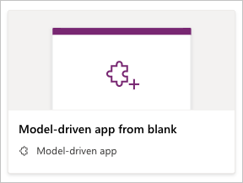

1. On the **Create a New App** page, enter a name and description for the app.
2. Select **Done**. Your new app appears in the App Designer, and you can now add components to it.

## Add components to your app

You add components to your app by using the App Designer.

1. Select the **Open the Site Map Designer** pencil icon to open the site map designer.

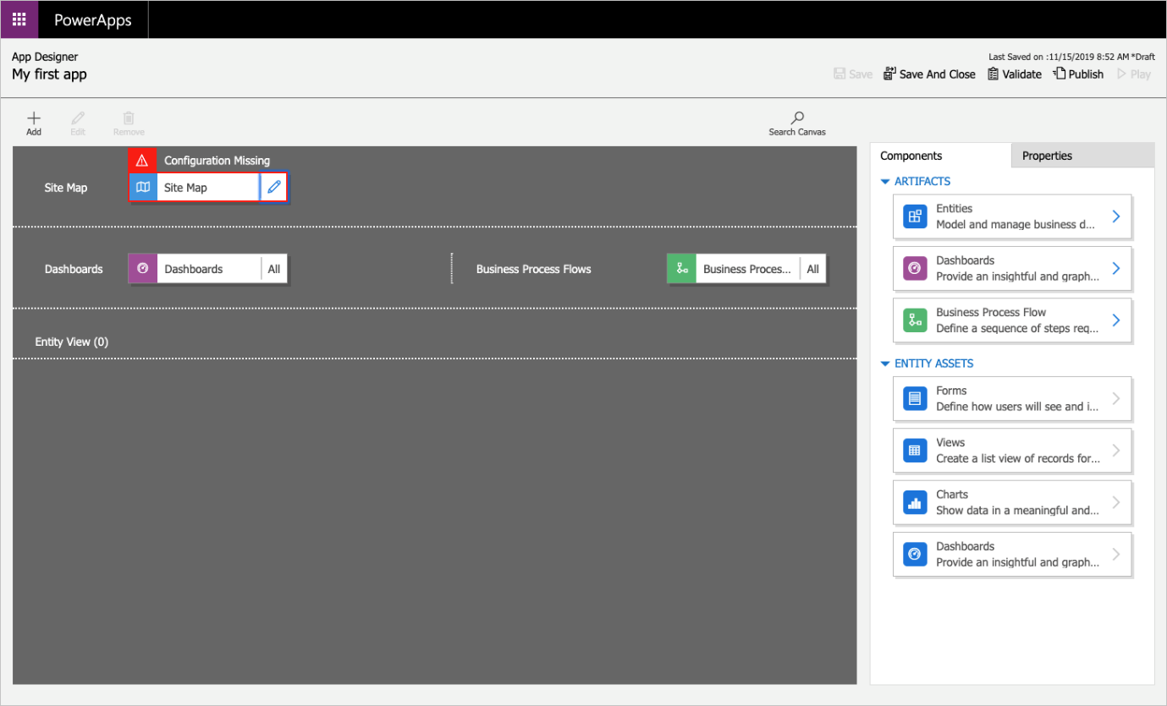

1. In the site map designer, select **New Subarea**, and then, in the right pane on the **Properties** tab, select the following properties:
   * **Type**: Entity
   * **Entity**: Account
2. 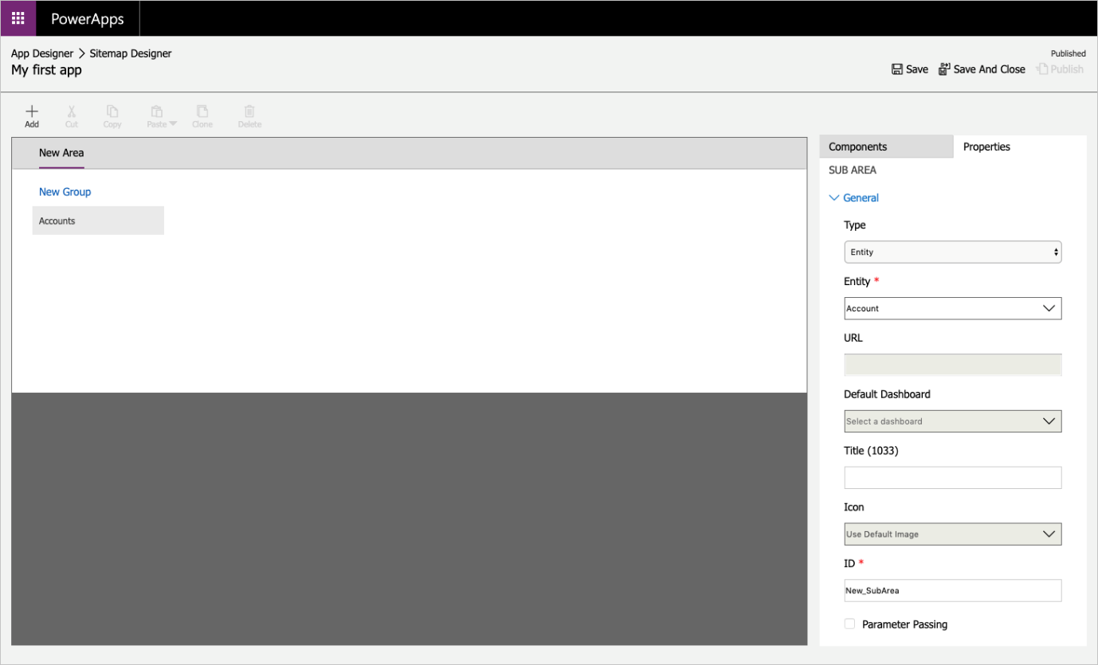
3. Select **Save And Close**.
4. In the App Designer, select **Forms**, and then, in the right pane under **Main Forms**, select the **Account** form.

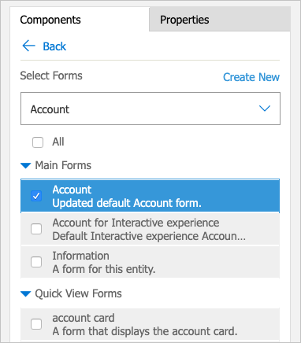

1. In the App Designer, select **Views**, then select the following properties:
   * Active Accounts
   * All Accounts
   * My Active Accounts
2. In the App Designer, select **Charts**, then select the **Accounts by Industry** chart.
3. On the App Designer toolbar, select **Save**.

**Publish your app**

On the App Designer toolbar, select **Publish**. After you publish the app, it's ready for you to run or share with others.

Above My Active Accounts, select **Show Chart**.

If the sample data for your accounts does not have an Industry populated, go into a few accounts and add an Industry. Once you have updated a few accounts with an industry the chart will update as well.

